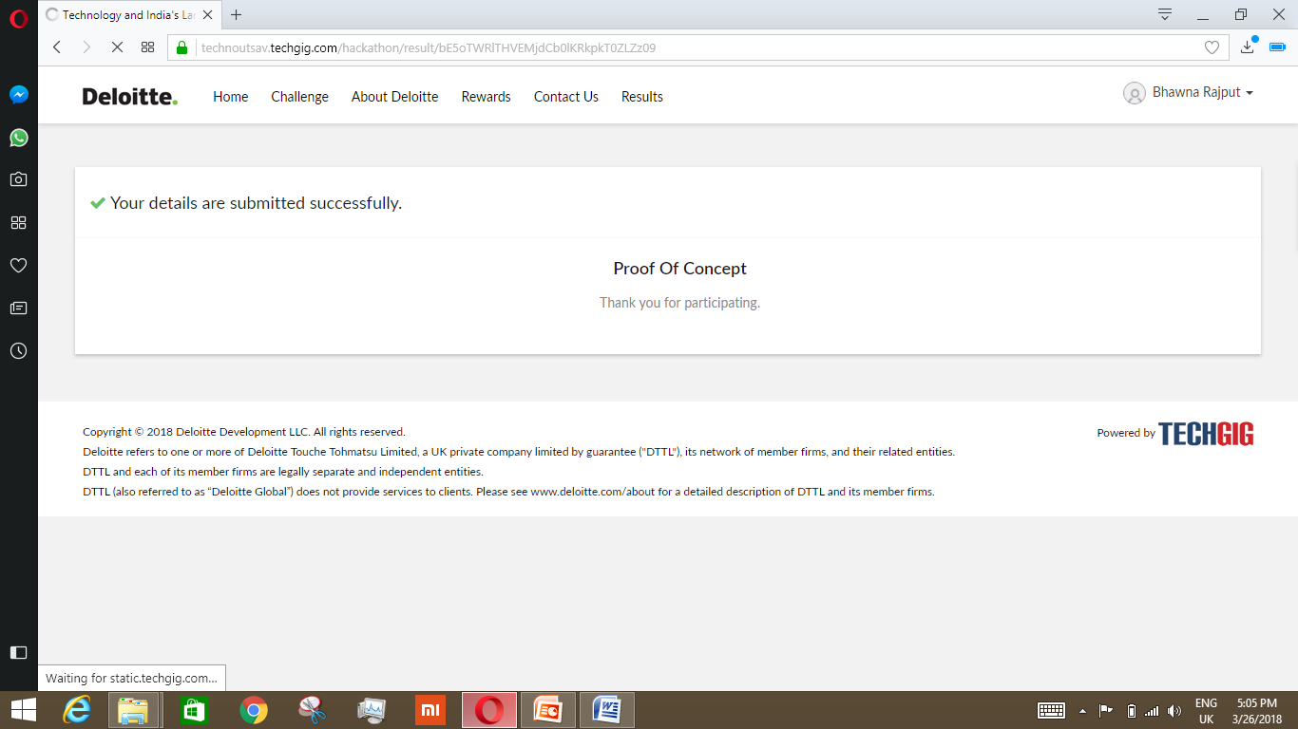v

Every one wants value of their Money , But in our day to day life we use to see the Frauds that usually happen at Petrol Pump that Now days ,that we Pay for more but we get less is output and everyone wants value to their Money